**AP ASSIGNMENT – SHIVAM GAUTAM – 22BCS12184**

1. Print Linked List –

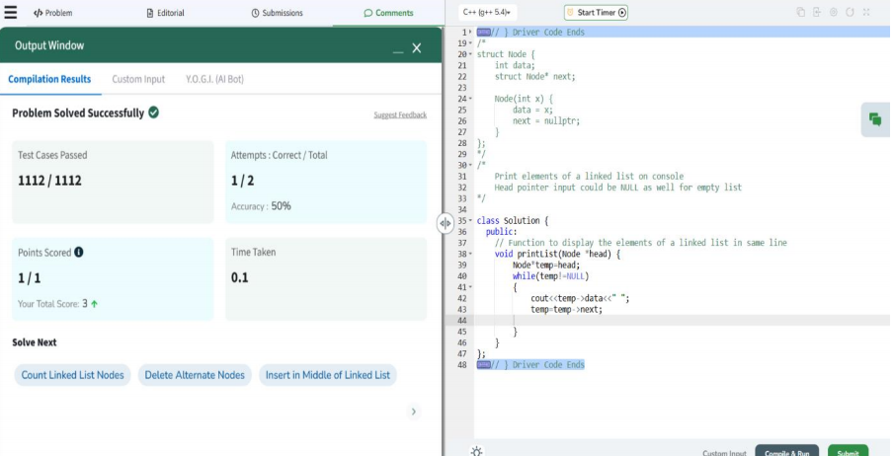

1. [Remove duplicates from a sorted list](https://leetcode.com/problems/remove-duplicates-from-sorted-list/description/) –

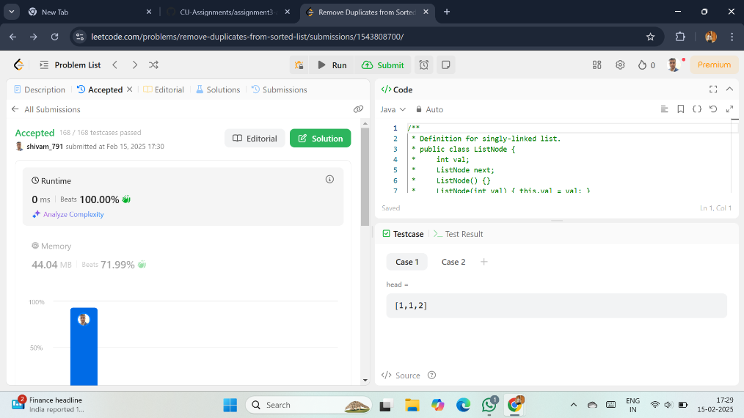

1. Reverse a linked list –

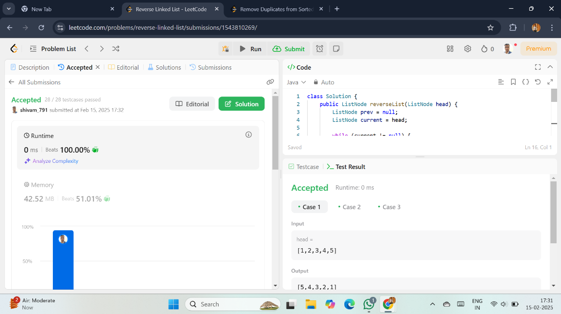

1. [Delete middle node of a list](https://leetcode.com/problems/delete-the-middle-node-of-a-linked-list/description/) -

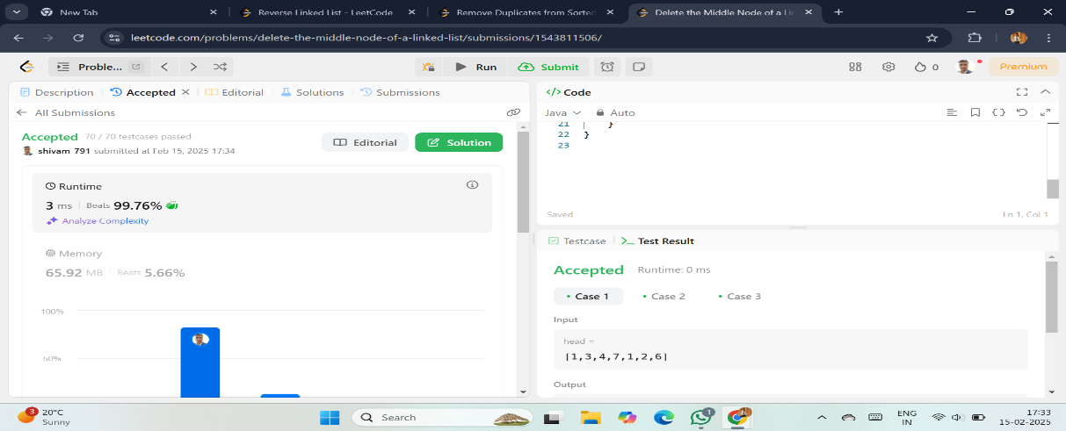

1. [Merge two sorted linked lists](https://leetcode.com/problems/merge-two-sorted-lists/description/) –

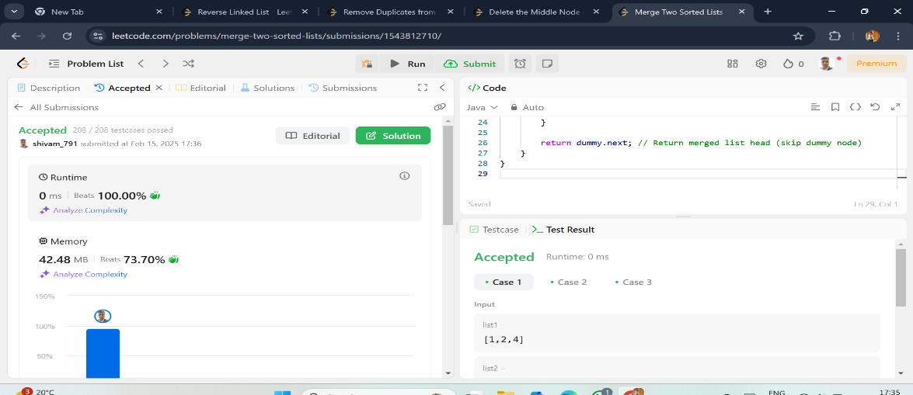

1. [Remove duplicates from sorted lists –](https://leetcode.com/problems/remove-duplicates-from-sorted-list-ii/description/)

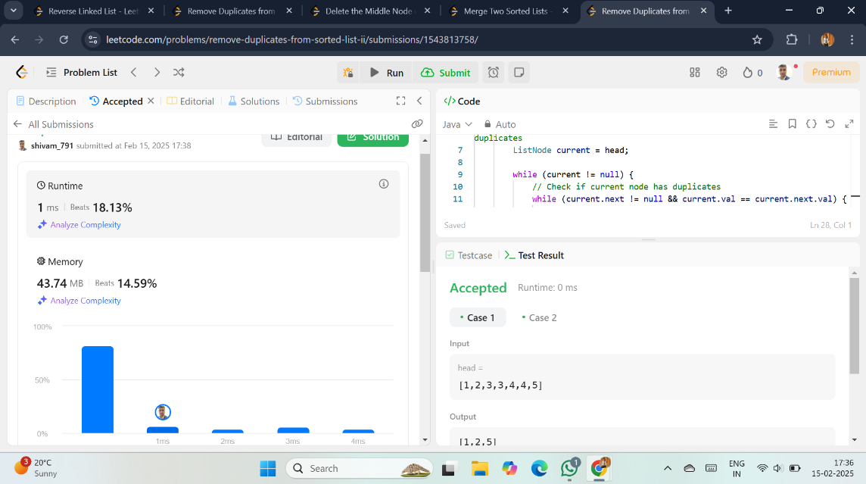

1. Detect a cycle in a linked list –

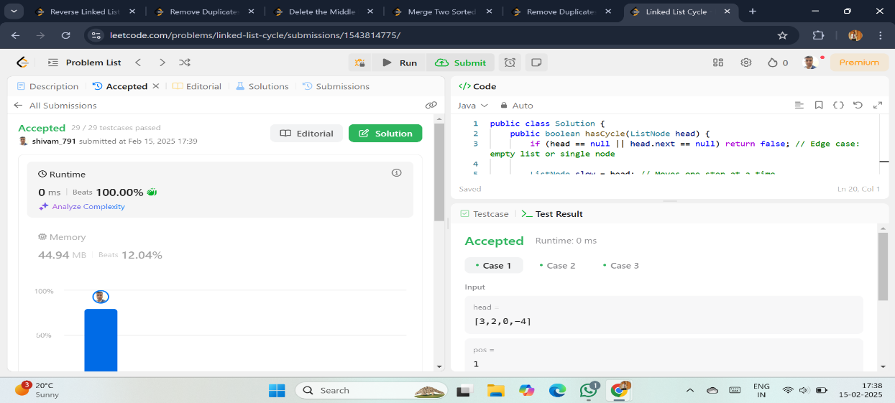

1. [Reverse linked list 2](https://leetcode.com/problems/reverse-linked-list-ii/description/) –

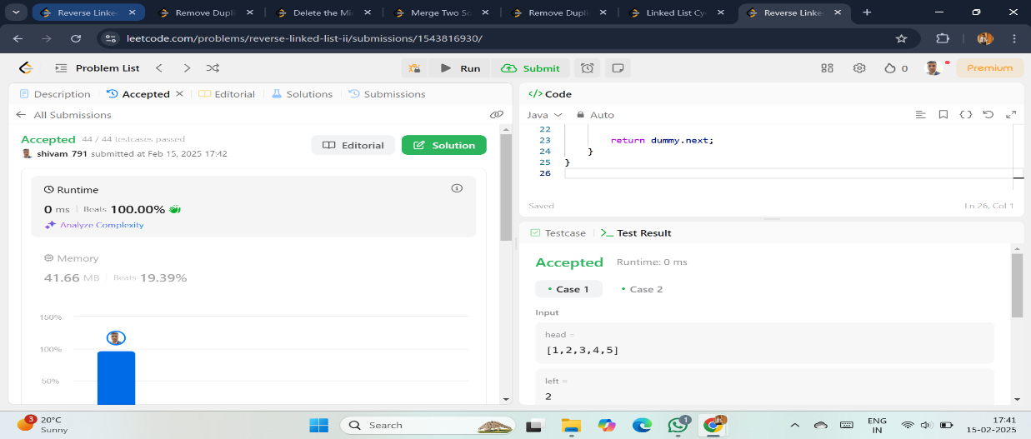

1. [Rotate a list](https://leetcode.com/problems/rotate-list/description/) –

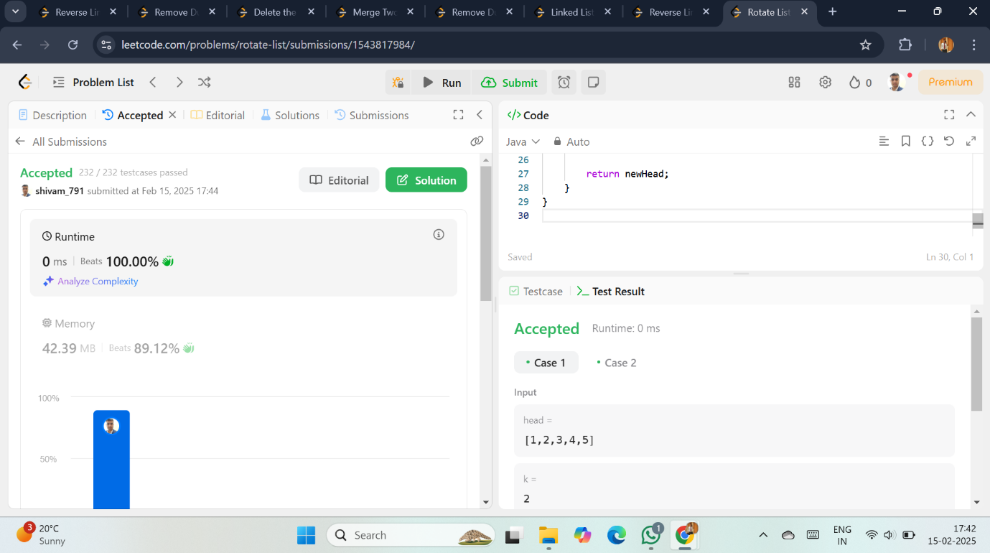

1. [Sort List](https://leetcode.com/problems/sort-list/description/) –

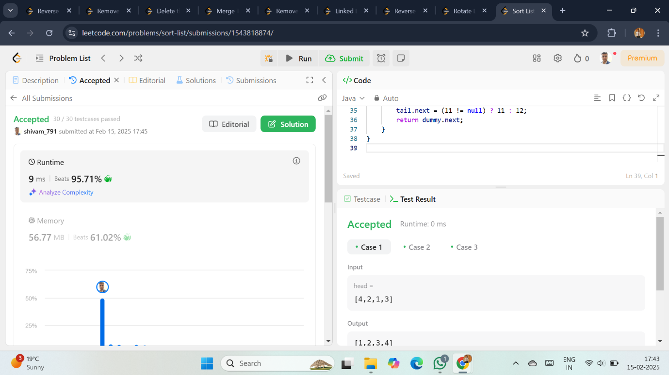

1. [Detect a cycle in a linked list 2](https://leetcode.com/problems/linked-list-cycle-ii/description/) –

